**CONTACT-MANAGEMENT APPLICATION**

**A SUMMER INTERNSHIP REPORT**

***Submitted by***

## VANAPARIYA DEEPKUMAR VIJAYBHAI 200410116022

***In Partial fulfillment for the award of the degree Of***

# BACHELOR OF ENGINEERING

***in***

# Information Technology



Sardar Vallabhbhai Patel Institute of Technology, VASAD. **Gujarat Technological University, Ahmedabad August, 2023**

**SARDAR VALLABHBHAI PATEL INSTITUTE OF TECHNOLOGY, VASAD.**

### INFORMATION TECHNOLOGY ENGINEERING 2022-23



CERTIFICATE

**Date: / /2023**

This is to certify that the Summer Internship Work entitled “CONTACT-MANAGEMENT SYSTEM” has been carried out by VANAPARIYA DEEPKUMAR VIJAYBHAI (200410116022) under my guidance in fulfillment of the degree of Bachelor of Engineering in Information Technology (7th Semester) of Gujarat Technological University, Ahmedabad during the academic year 2023-24.

### Internal Guide Head of the Department

Prof. Pradish Dadhania Dr. B J. Talati

### Asst. Prof. IT Dept.

SVIT,VASAD SVIT,VASAD

# ACKNOLEDGEMENT

This report has been prepared for the Summer Internship Project on topic contact Management System Web- site to implement the theory in the real field with the purpose of fulfilling the requirements of this course.

The aim of this project is to make familiar to the practical aspect and uses of theoretical knowledge and clarifying the career goals, so we have successfully completed the project and compiled this report as the summary and the conclusion that we have drawn from the project.

We perceive as this opportunity as a big milestone in our career development. I will strive to use gained skills and knowledge in the best possible way, and We will continue to work on their improvement.

We would like to express our sincere gratitude to our Project Coordinator Prof. Pradish Dadhania who had given his valuable time and given us chance to learn something despite having his busy schedule.

- Deep Vanapariya (200410116022)

# ABSTRACT

Contact-management System is a project which aims in developing an Web application to provide Easy usage Experience, faster operation perform. This System can be used to Add New contact, Delete contact. User can search and performing separate from other. This app provide fater data retrieve and realtime data update rather then traditional application.

# List of Figures

1. Incremental Model 3
2. Use Case Diagram 7
3. Class Diagram 7
4. Sequence Diagram 8
5. Activity Diagram 8
6. Algorithm Flow 9
7. coding standerds… 10
8. Home Page 11
9. Create Page 12
10. View Page 12
11. Update Page 13

# List of Tables

1. Data Dictionary 9

# List of Abbreviations

**HTML:** Hyper Text Markup Language

**CSS:** Cascading Style Sheet

**JS:** Java Script

**CPU:** Central Processing Unit

**OS:** Operating System

# Index

Acknowledgement 3

Abstract 4

List of Figures 5

List of Tables 6

List of Abbreviations 7

Index

1. Introduction 1
   1. Introduction 1
   2. Existing System 1
   3. Need for the new System 1
   4. Objective of the New System 1
   5. Problem Definition 2
   6. Software Process Model 2
   7. Core Components 4
   8. Project Profile 4
   9. Advantages and Limitations of the Proposed System 4
2. Requirement Determination & Analysis 15
   1. Requirement Determination 5
      1. Functional Requirement 5
      2. Non Functional Requirements 5
      3. Hardware Requirements 5
      4. Software Requirements 6
   2. Targeted User 6
3. System design 7
   1. Use Case Diagram 7
   2. Class Diagram 7
   3. Sequence Diagram 8
   4. Activity Diagram 8
   5. Data Dictionary 9
   6. Algorithm Flow 9
4. Development 10
   1. Coding Standards 10
   2. User Interface 11
5. Future Enhancement 14
6. Conclusion 15
7. References 16

## 1 Introduction

### Introduction

In this chapter, the experience of work placement and overall tasks of the Web Application is discussed: The requirement for a Bachelor’s in Information Technology is that student must do training in order to gain experience necessary in the technological field. The work must be theoretical and practical work. The project was carried to learn practical knowledge. The experience and skills that are gained and challenges which are faced in solving problems during this period. Project has included various activities but mainly were learning and implementing the knowledge by building Reactjs Web Application.

### Existing System

my project is a contact-manager app based on CRUD operation. Their are many similar application in the world but they not having user friendly interfaces and the most useful feature like real time update without loading. Contact-manager is come with all the systems like Adroid,Ios &Widows. They don’t have much loading and take time while updating data.

Once user register/Create contact he can do update and view also he can delete that contact. User must have to fill up all the require information which will be use to create new contact registration to the database.

### Need for the new System

To overcome the Existing systems problem and providing user friendly interface. There are many similar kind of application out there. The application which i have done it is simple to use and the user data will safely stored in the system. User have experience of new functionality of the system. Contact- manager save data which normal system not saves like company name,title as position in the organisation and particular contact relation with us as a friend,colleage,family,social,service and community with picture represantation.

### Objective of the New System

The primary objective of a contact management system is to efficiently organize and store contact information. The system aims to make it easy to retrieve contact information when needed. This might involve search features, filters, and sorting options to quickly find specific contacts. The objective might involve creating an intuitive and user-friendly interface that makes it easy for users to navigate and use the system effectively.

### Problem Definition

This is a contact-manager app which provides user-friendly interface with easy to use and find the contact. Data will represented in real time data updation there are many similar kind of application but this is build up in react js which adds easy and fast data retrival features to the application.

Contact-manager application will helps to view and update easy way rather then doing in cloud data retrieve. It preform very faster and keep refreshing database which ever operation is going to preforms by the user in user interface.

### Software Process Model

The Software Process Models are the various processes or methodologies that are being selected for the development of the project depending on the project’s aims and goals. There are many development life cycle models that have been developed in order to achieve different required objectives. The models specify the various stages of the process and the order in which they are carried out.

The selection of model has very high impact on the testing that is carried out. It will define the what, where and when of our planned testing, influence regression testing and largely determines which test techniques to use.

Choosing right model for developing of the software product or application is very important. Based on the model the development and testing processes are carried out.

A Process Model describes the sequence of phases for the entire lifetime of a product. Therefore it is sometimes also called Software Life Cycle. This covers everything from the initial commercial idea until the final de-installation or disassembling of the product after its use.

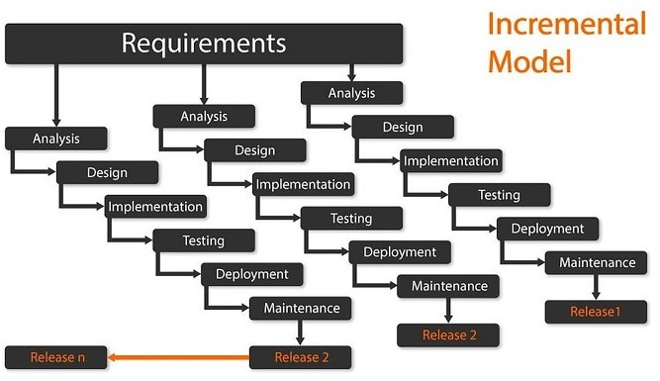

In order to develop the project “Contact-manager” we have adopted the Iterative Enhancement Model also known as Incremental Model. This model removes the shortcoming of waterfall model. Since many facts of this system are already known. It is not a new concept and hence no research is required. A working version can be easily created and hence the system can start working. Rest of the functionalities can be implemented in the next iteration and can be delivered later. As the requirement analysis is also not required. It not being a new technology risk involved is also less. So one need not perform detailed risk analysis. If redevelopment staff is less than development can be started with less number of people and in next increments others can be involved.

As this model combines the advantage of waterfall model and prototyping, clients are always aware of the product being delivered and can always suggest changes and enhancements and can get them implemented. As less amount of customer communication is required one need not apply spiral model in which all types of analysis is done in detail.

As the deadline is affordable one need not to for Rapid Application Development model. Iterative enhancement model is useful when less manpower is available for software development and the release deadlines are specified. It is best suited for in house product development, where it is ensured that the user has something to start with. The complete product is divided into releases and the developer delivers the product release by release

### Core Components

in the contact-manager application core component will be server which will be store contact data and most important react component which display data and retrive based on user choice. In our case we use json-server which will create ‘.json’ file in our project directory and through live server. Here’s important components:

1. A set of features that allow the creation, management, update and delete.
2. A user interface

### Project Profile

Contact-manager application will store your contact data as well as the additional information also stored and display to the user in structured way. All this operation are perform with real time updation this makes application unique from the traditional approach.

### Advantages and Limitations of the Proposed System

Advantages:-

* fast data retrieve
* user-friendly
* Data Security
* Scalability
* Efficient Contact Organization

Limitations:-

* + there are no cloud storage only local file storage
  + login
  + authentication

# 2 Requirement Determination &amp; Analysis

### Requirement Determination

Requirement determination, also known as requirements elicitation or requirements gathering, is a critical phase in the software development process. It involves identifying, understanding, and documenting the needs and expectations of stakeholders for a software project. This phase lays the foundation for creating a clear and comprehensive set of requirements that guide the development team throughout the project lifecycle.

## Functional Requirement

* + - * Itemize the detailed functional requirements associated with the features of vision document.
      * These are the software capabilities that must be present in order for the user to carry out the services provided by the feature.
      * Include how the product should respond to anticipated error conditions or invalid inputs. Requirements should be concise, complete, unambiguous, verifiable.
      * all field in contact creation must have to fill up
      * email should be valid

## Non Functional Requirements

* + - * Server must running background while performing operations
      * Required port no. Must free while working with application
      * Browser support
      * Usability
      * Reliability
      * Performance
      * Supportability
      * Safety
    1. Hardware Requirements

|  |  |
| --- | --- |
| Processor | 1.6 GHz or Faster processor |
| RAM | 4 GB |
| Disk Space | 3 GB of available Hard Disk |
| Graphic | DirectX 9-Capable Video Card |
| Display | 1024 X 768 or Higher Resolution |

* + 1. Software Requirements

|  |  |
| --- | --- |
| Operating System | Windows 11 |
| Front End | Reactjs,HTML,CSS,JS |
| Back End | JS |
| Library/Framework | Bootstrap, FontAwesome |
| Code Editor | Visual Studio Code |
| Database | json |
| Web Server | json-server |
| Web Browser | Google Chrome |
| Drawing Tools | Lucidchart |

### Targeted User

* working professional
* student
* worker

# 3 System design

### Use Case Diagram

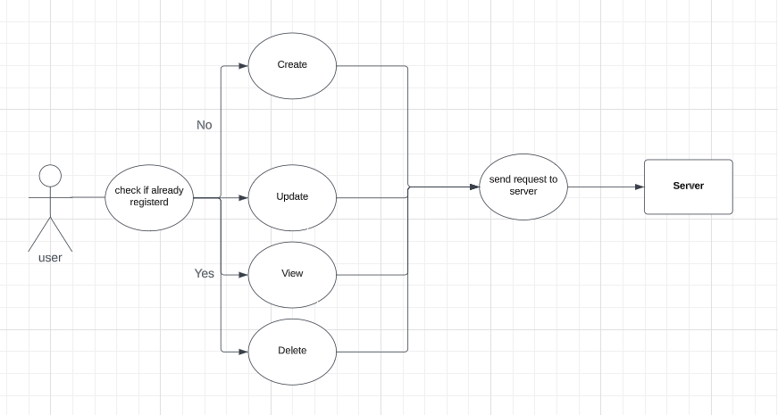

### Class Diagram

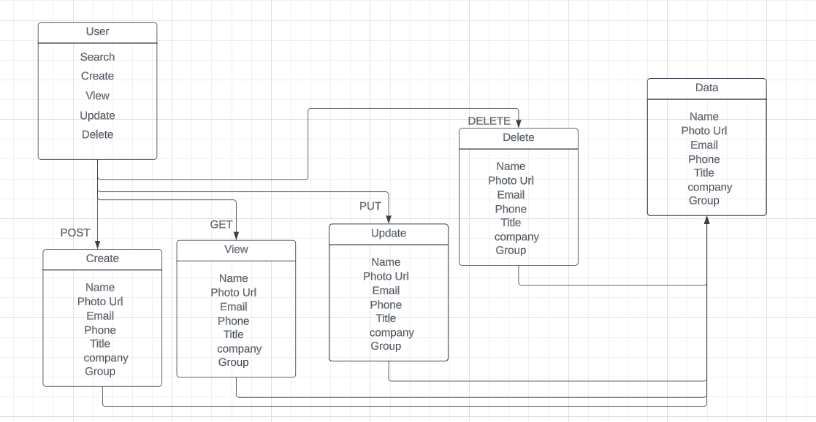

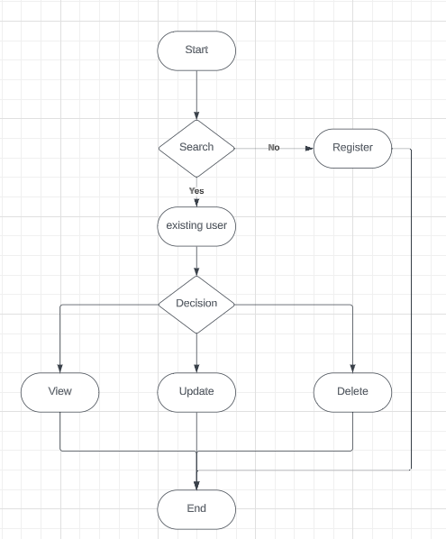

### Sequence Diagram

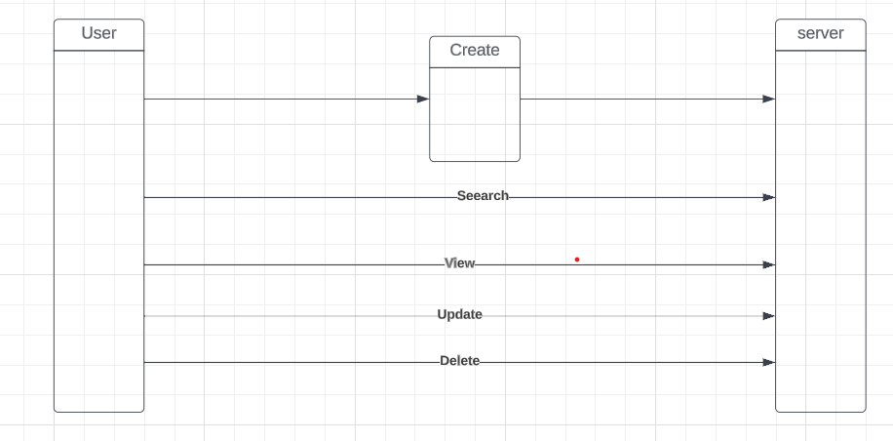

* 1. Activity Diagram

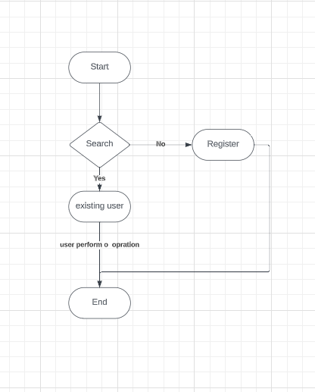

### Data Dictionary

|  |  |  |  |
| --- | --- | --- | --- |
| **Data Item** | **Data Type** | **Description** | **Example** |
| name | String | Contact identify | Deep |
| photo_url | String | Picture of contact | xyz.com |
| email | String | Email id of contact | [deep@gmail.com](mailto:deep@gmail.com) |
| company | String | Company name | Google |
| mobile | number | Phone number | 1234567890 |
| title | String | Designetion of contact | Software Devloper |
| group | String | Relation of contact | friend |

### algorithm flow

# 4. Development

### Coding Standards

1. Folderize your Components (all related files in one folder). Below is the folder structure with naming conventions to be used.

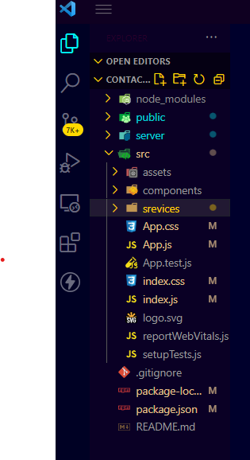

1. Naming: File and component name need to be identical.
2. Alignment of Declaration Blocks − Block of declarations should be aligned.
3. One Statement Per Line − There should be only one statement per line unless the statements are very closely related.

### User Interface Home page:-

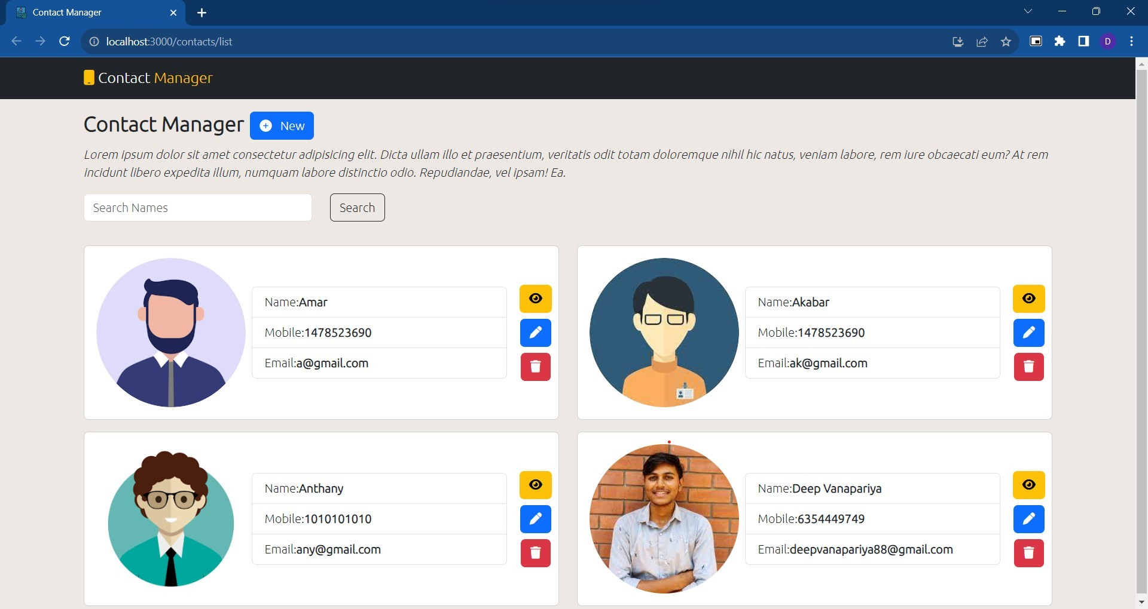

Create Page:-

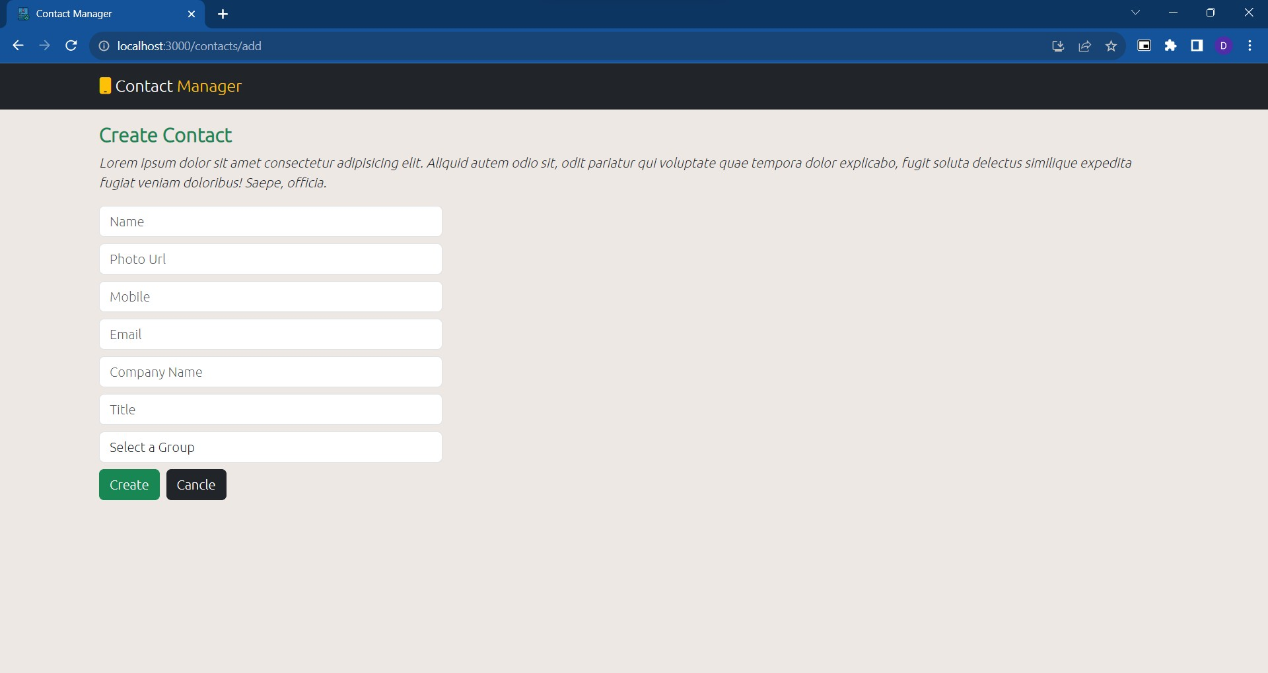

### View page:-

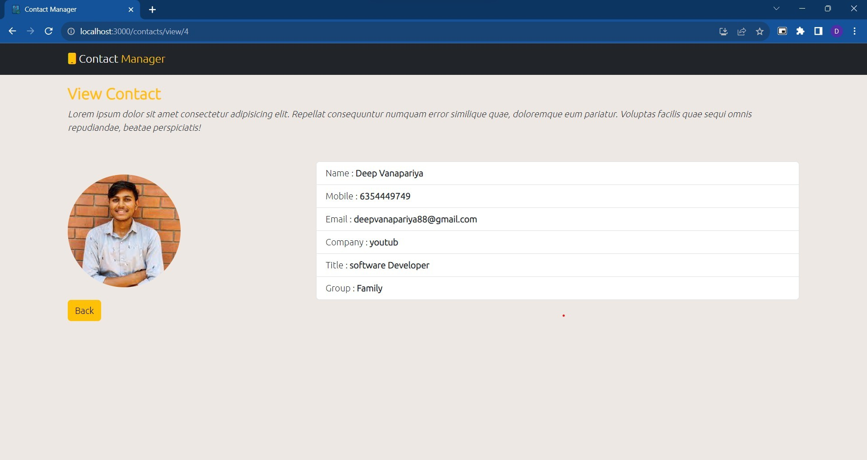

Update page:-

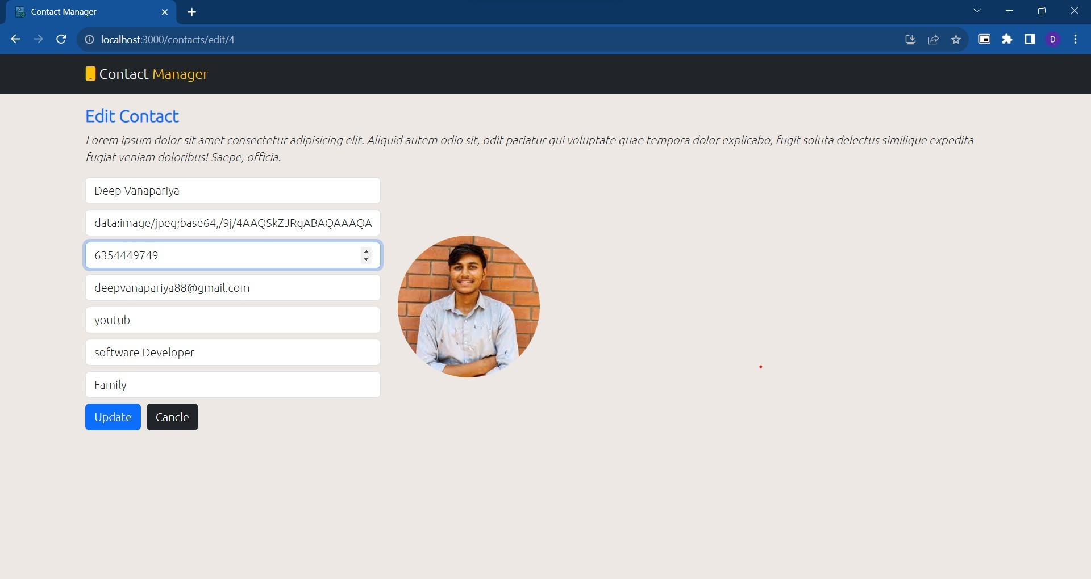

# Future Enhancement

Currently Single admin is able to manage the content, So More than one admin can be added. Currently use local storage therfore in future we have to use cloud to store data.

Login and authentication of the use need to implement.

Subscription model will be made available where user can select the plan and can access the premium fetaure.

# Conclusions

Contact-management Application is computed successfully and contains all the required functionality. It is user friendly, which can be utilized by the user to perform the desired operations.

The Software is developed using HTML, CSS ,Reactjs as front end and JS, json as back end in windows environment.

* Goals achieved by the application are :
* User friendly – easy to use
* Portable and flexible for further enhancement
* Can be accessed on any operating system having browser andinternet connection

# References

### Web Resources

1. [https://react.dev](https://react.dev/)
2. <https://getbootstrap.com/docs/4.6/getting-started/introduction/>
3. [www.fontawesome.com](http://www.fontawesome.com/)
4. [www.w3schools.com](http://www.w3schools.com/)
5. [www.youtube.com](http://www.youtube.com/)